**Exploring Box Office Success: Insights for Microsoft's New Movie Studio**

**Section 1: Highest Profitable Genres**

**Page 1.1: Top 5 Highest Profitable Genres**

* **Horror Genre**: The most profitable genre in the box office, making it a valuable investment decision and trend identifier.
* **Adventure Genre**: Shows strong profitability, making it a potential lucrative genre for movie production.
* **Family Genre**: Demonstrates significant profitability, indicating a favorable market for family-oriented films.
* **Sci-Fi Genre**: Shows promising profitability, suggesting a potential audience interest in science fiction movies.
* **Action Genre**: Currently the least profitable genre, indicating a challenging market for action films.

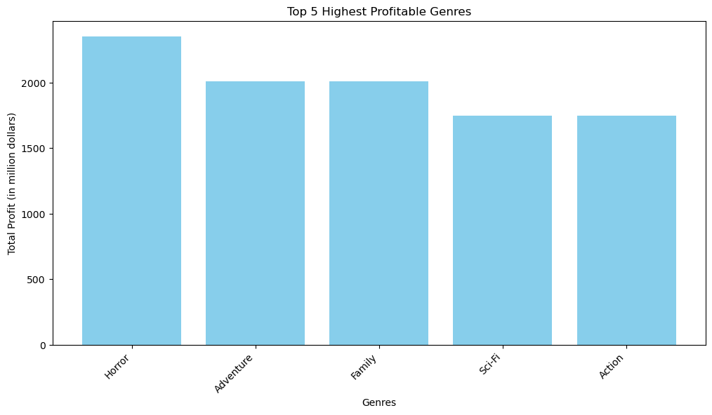

**Page 1.2: Insights on Profitable Genres**

* **Horror Dominance**: The horror genre emerges as the most profitable, providing valuable insights for investment decisions and industry trend identification.
* **Action Genre Challenges**: Action movies currently exhibit the lowest profitability, indicating a need for careful consideration and strategic planning in this genre.

**Page 1.3: Top 5 Genres with Highest ROI**

* **Horror Genre**: Exhibits the highest Return on Investment (ROI) among all genres, making it a strong candidate for financial success.
* **Thriller Genre**: Shows a close second in ROI, indicating a potential for strong financial returns.
* **Mystery Genre**: Follows closely behind, suggesting a favorable financial outlook for mystery films.
* **Documentary Genre**: Demonstrates a strong ROI, making it a viable genre for financial success.
* **Biography Genre**: Shows potential for strong financial returns, making it a favorable genre for consideration.

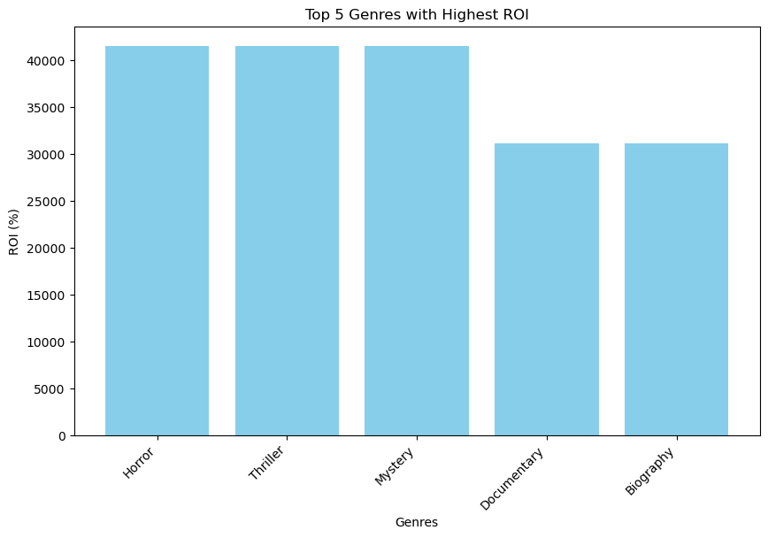

**Page 1.4: Insights on ROI by Genre**

* **Horror Genre**: Emerges as the genre with the highest ROI, providing valuable insights for selecting genres with strong financial returns.
* **Thriller and Mystery Genres**: Follow closely behind, indicating potential for strong financial success in these genres.

**Section 2: Studios with Highest ROI**

**Page 2.1: Top 5 Studios with Highest ROI**

* **WB (NL)**: Leads with the highest Return on Investment (ROI), making it a valuable consideration for partnership and collaboration.
* **UTV**: Demonstrates a strong ROI, indicating potential for successful collaboration and partnership.
* **FD**: Shows a favorable ROI, making it a potential partner for successful movie production.
* **ParV**: Exhibits a strong ROI, suggesting potential for successful collaboration and partnership.
* **Orchard**: Demonstrates a favorable ROI, indicating potential for successful collaboration and partnership.

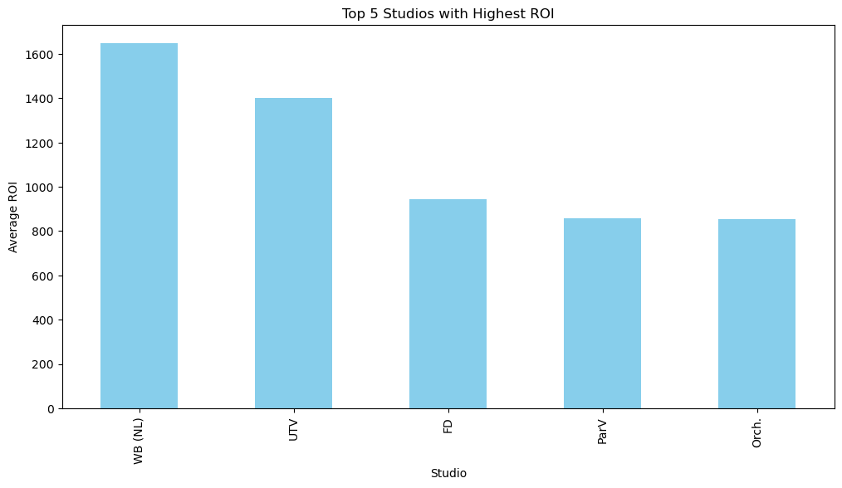

**Page 2.2: Insights on Successful Studios**

* **WB (NL)**: Leads with the highest ROI, providing valuable insights for partnership considerations and understanding successful studios.
* **Collaboration Potential**: Understanding the studios with the highest ROI is crucial for strategic collaboration and partnership decisions.

**Page 2.3: Genre Analysis: Horror, Thriller, Mystery**

* **Average Runtime**: Horror (90 minutes), Thriller (95 minutes), Mystery (98 minutes)
* **Average Rating**: Horror (5), Thriller (6), Mystery (6)

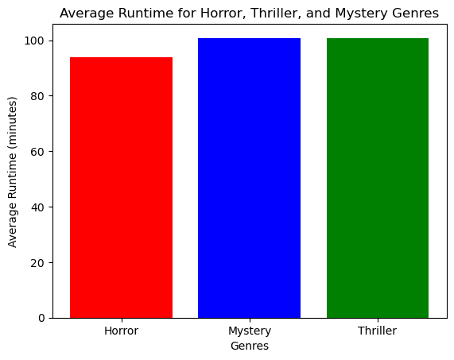

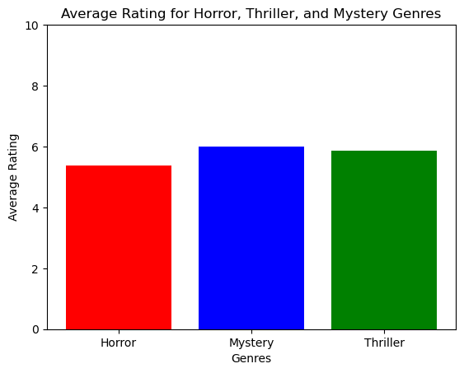

**Page 2.4: Insights on Genre Analysis**

* **Horror Genre**: Exhibits a shorter average runtime but maintains a decent average rating, indicating potential for financial success.
* **Thriller and Mystery Genres**: Tend to have longer runtimes and higher average ratings, suggesting potential for strong audience engagement and financial success.

**Section 3: Summary and Actionable Insights**

**Page 3.1: Key Insights**

* **Horror Genre**: Emerges as a lucrative genre with high profitability and ROI, making it a strong candidate for movie production.
* **WB (NL)**: Stands out as the studio with the highest ROI, providing valuable insights for collaboration and partnership decisions.
* **Considerations for Success**: Genre-specific runtime and audience ratings are crucial for strategic decision-making in movie production.

**Page 3.2: Empowering Microsoft's Movie Studio**

* **Strategic Genre Selection**: Insights will empower Microsoft's movie studio to strategically choose genres with high profitability and ROI.
* **Collaboration with Successful Studios**: Understanding successful studios will ensure a strong entry into the competitive world of movie production.

**Page 3.3: Actionable Insights**

* **Strategic Decision-Making**: Use insights to make informed decisions on genre selection and studio collaboration.
* **Competitive Entry**: Ensure a strong and competitive entry into the movie production industry through strategic genre selection and collaboration.

**Page 3.4: Conclusion**

* **Strategic Decision-Making**: These insights will empower Microsoft's movie studio to strategically choose genres and collaborate with successful studios, ensuring a strong entry into the competitive world of movie production.
* **Actionable Insights**: Use the provided insights to make informed decisions and drive success in the movie production industry.

Top of Form

Bottom of Form